Operations on Fuzzy sets:
- Operations on fuzzy sets is done by means of their membership functions.
- Let A and B be fuzzy sets on a mutual universe.

Intersection of A and B is: A ∩ B = a min b
The operation min is an item-by-item comparison between corresponding items in a and b.
Union of A and B is: a max b
The operation max is an item-by-item maximum operation.
Complement of A is: where each membership value in a is subtracted from 1.

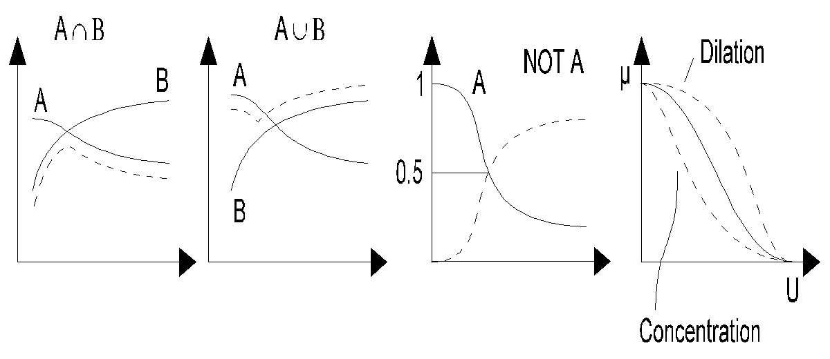

Q 1:
It is necessary to compare two sensors based on their detection levels (D₁, D₂) and gain settings (X). Below table shows the gain settings and detection levels of the sensors. Find the followings:
a) b) c) d)
e) f)

Gain | Detection Level Sensor-1 | Detection Level Sensor-2
0 | 0 | 0
10 | 0.2 | 0.35
20 | 0.35 | 0.25
30 | 0.65 | 0.8
40 | 0.85 | 0.95
50 | 1 | 1

Solution:
Given the universe of discourse X = {0, 10, 20, 30, 40, 50} and the membership functions for the two sensors:
and

a)

b)

c)

d)

e)
Here,
From part (c):

So,

f)
Here,
From part (c):

So,

Q 2:
Consider the following two fuzzy sets:
and

Perform the Cartesian product over theses given fuzzy sets.

Solution:
The fuzzy Cartesian product performed over fuzzy sets A and B results in fuzzy relation R given by R = AxB.
x₁

x₂

x₃

y₁ y₂

Calculation of membership values at each point:

Therefore,

Q-3:
Consider the following two fuzzy sets:

Find the algebraic sum, algebraic product, bounded sum, and bounded difference of the given fuzzy sets.

Solution:
(a) Algebraic Sum:

(b) Algebraic Product:

(c) Bounded Sum:

(d) Bounded Difference

Q-4:
Consider the following two fuzzy sets:

Find the algebraic sum, algebraic product, bounded sum, and bounded difference of the given fuzzy sets.

Solution:
(a) Algebraic Sum:

(b) Algebraic Product:

(c) Bounded Sum:

(d) Bounded Difference

Q-5:
Consider two given fuzzy sets:

Perform union, intersection, difference and complement over the given fuzzy sets.

Solution:
(a) Union:

(b) Intersection:

(c) Complement:

(d) Difference:
(i)

So,

(ii)

So,

Q-6:
Let U = {a, b, c, d} be the domain and A and B be fuzzy sets on U as given below:

 | a | b | c | d
A | 0.5 | 0.8 | 0.0 | 0.3
B | 0.2 | 1.0 | 0.1 | 0.7

Find i) AUB ii) A∩B iii) A/
iv) B/ v) Also prove (AUB)/ = A/∩B/

Solution:
i) AUB = {(x, µ(x)) | µ(x) = max{µ_{A}(x), µ_{B}(x)}, x ɛ X}
AUB = {(a, 0.5), (b, 1.0), (c, 0.1), (d, 0.7)}

ii) A∩B = {(x, µ(x)) | µ(x) = min{µ_{A}(x), µ_{B}(x)}, x ɛ X}
A∩B = {(a, 0.2), (b, 0.8), (c, 0.0), (d, 0.3)}

iii) A/= {(x, µ_{A}/(x)) | µ_{A}/(x) = {1 - µ_{A}(x)}, x ɛ X}
A/= {(a, 0.5), (b, 0.2), (c, 1.0), (d, 0.7)}

iv) B/ = {(x, µ_{B}/(x)) | µ_{B}/(x) = {1 - µ_{B}(x)}, x ɛ X}
B/= {(a, 0.8), (b, 0.0), (c, 0.9), (d, 0.3)}

v) Prove (AUB)/ = A/∩B/
LHS = (AUB)/ = {(a, 0.5), (b, 0.0), (c, 0.9), (d, 0.3)}
RHS = A/∩B/ = {(a, 0.5), (b, 0.0), (c, 0.9), (d, 0.3)}
This proves that LHS = RHS.

